**Project Report**

**Title: Event Management System**

## BACHELOR OF TECHNOLOGY

Computer science and Engineering

Submitted to:

## Ms. Nausheen Fatima

**LOVELY PROFESSIONAL UNIVERSITY PHAGWARA, PUNJAB**

Submitted by:

Riya Patel

Reg No. – 12203486

|  |  |  |
| --- | --- | --- |
| **Riya Patel** | **12203486** | **69** |
| **Pranjal Thakur** |  | **29** |
| **Priya Sirohi** |  | **06** |

**Group Members Name:- Reg***.***No:- Roll.No:-**

# ACKNOWLEDGEMENT



I would like to express my special gratitude to our faculty Ms. Nausheen Fatima ma’am for giving us such an opportunity to work on this project of designing an event management system using HTML and CSS.

I would also like to thank my group members who helped me complete this project.

***DESIGN AND SOURCE CODE:-***

**This is the code’s screenshot and the code of this is at the next page,**

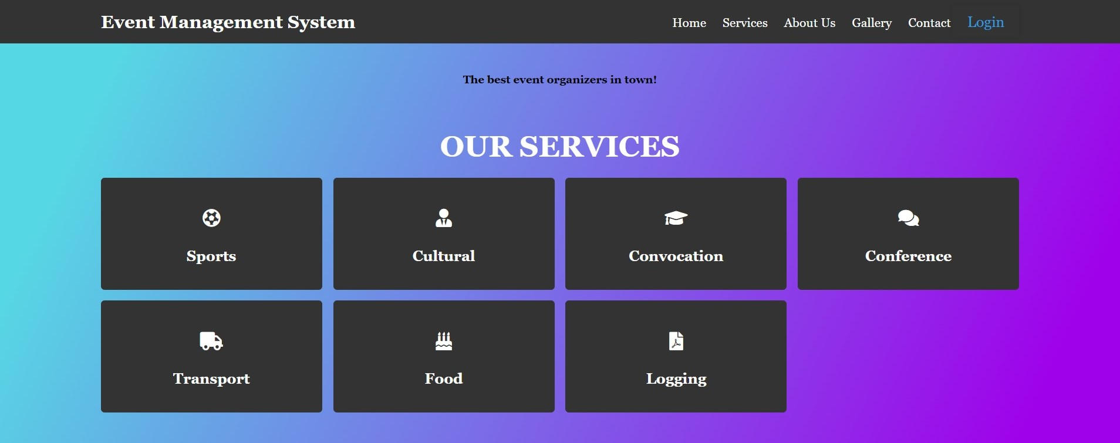

***SOURCE CODE:-***

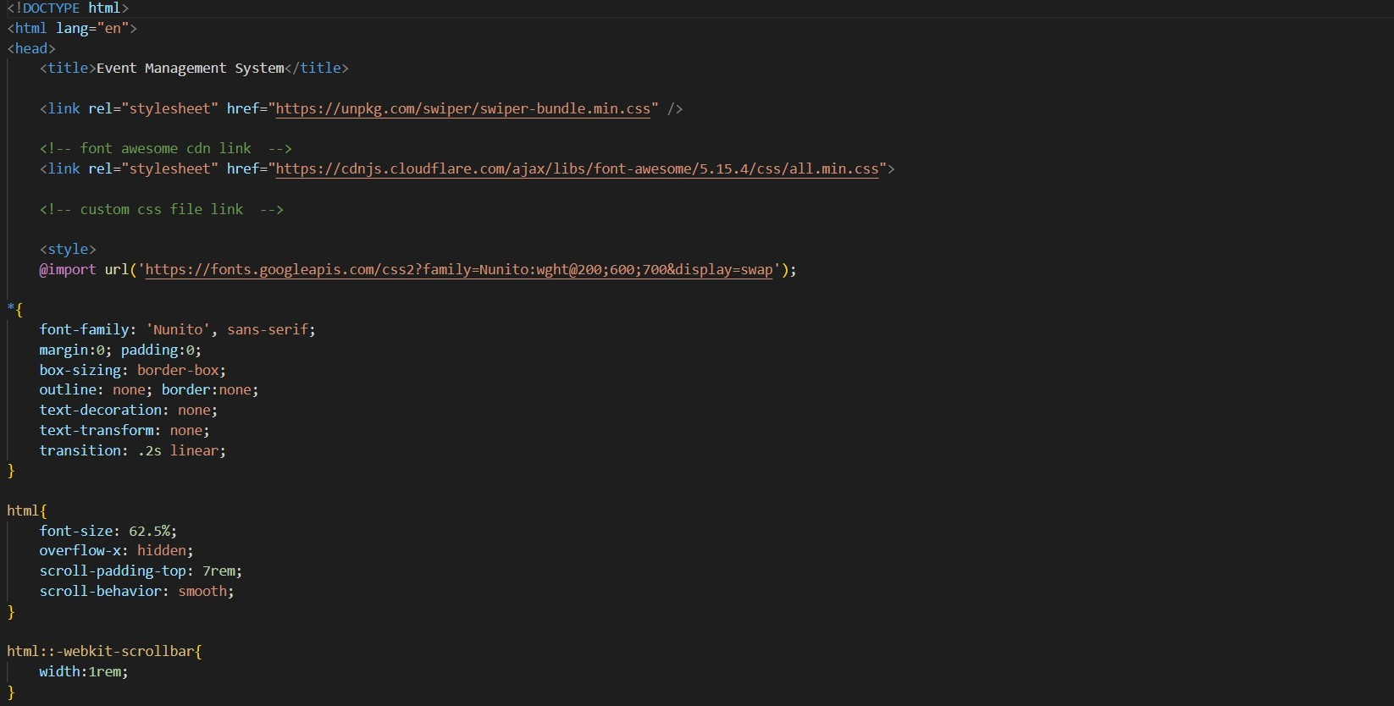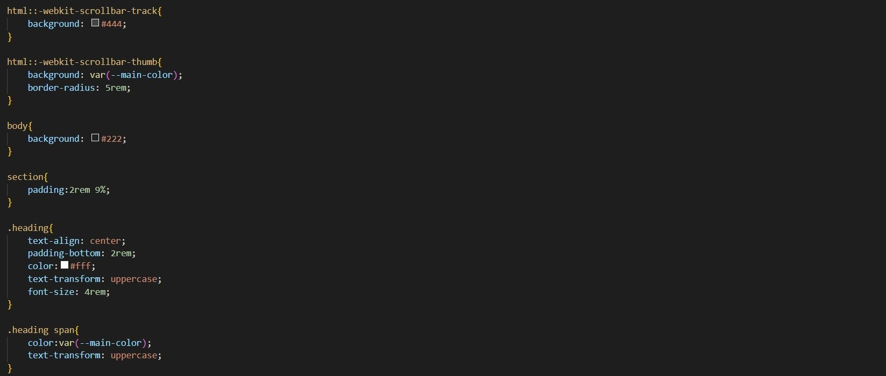

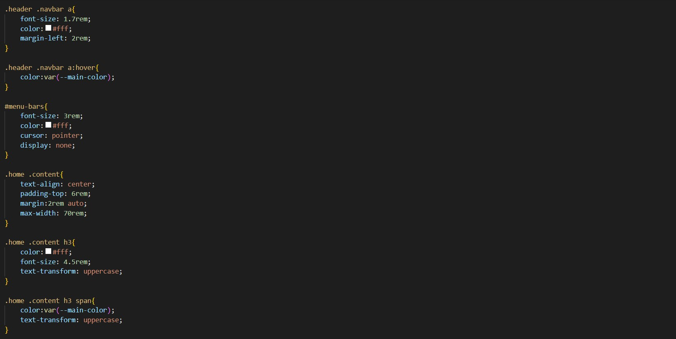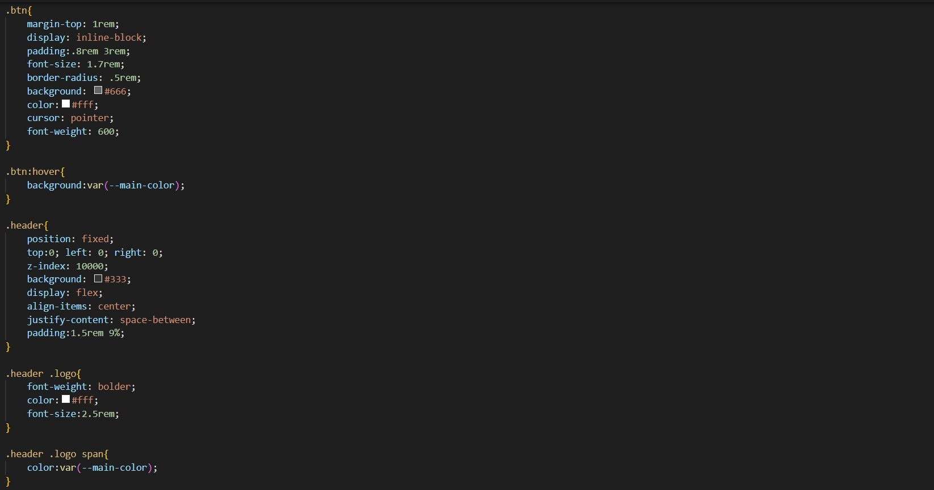

Result page/Output:-

# Conclusion

